**YONNYO**

**TWO WHEELED BIN - DATA SHEET**

Volume- 80 litre

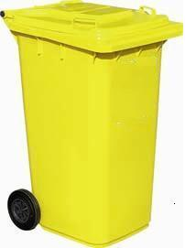

• High quality, high density HDPE

• Robust design and construction

• Solid steel axle

**DESCRIPTION**

Type: Storage Bucket

Usage: Outdoor

Place of Origin: Zhejiang,China

Volume: 80 Litre

Material: Virgin HDPE

Wall Thickness: 3mm

Weight: 5.6Kg

Size: L560mm*W470mm*H665mm

Shape: Rectangular

Feature: Eco Friendly

TRAVELLING GEAR - EXTERNAL WHEEL Ø 190MMRUBBER TYRED WHEELS, SOLIDWHEEL AXLE FROM TEMPERED, GALVANISED STEEL

**TECHNICAL DATA**

**TECHNI**

|  |  |  |  |  |
| --- | --- | --- | --- | --- |
| **BIN MODEL** | **CAPACITY** | **DIMENSIONS** | **USEFUL LOAD (KG)** | **MATERIAL** |
| **YY-80** | **80 LTR** | **470mm W X 560mm L X 665mm H** | **5.6Kg** | **Virgin HDPE** |

**CAL DATA**